(SINDH TECHNICAL EDUCATION & VOCATIONAL TRAINING AUTHORITY)

GOVERNMENT
COLLEGE OF TECHNOLOGY
HYDERABAD

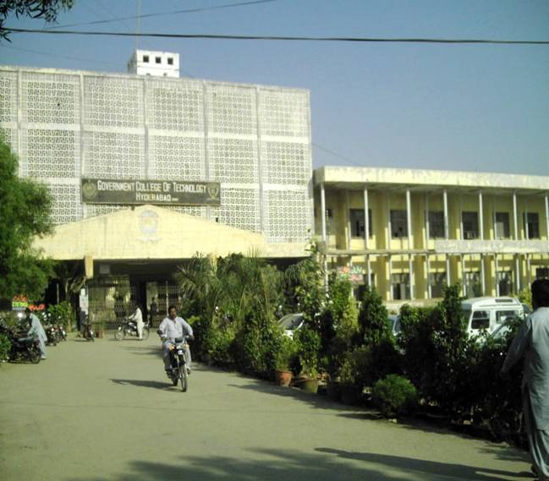

SURVEY REPORT HYDERABAD DIVISION OCTOBER 2008

1. Summary of Survey
GOVERNMENT COLLEGE OF TECHNOLOGY, HYDERABAD.

District Hyderabad – Province Sindh – Pakistan

INTRODUCTION
The present GCTH was first established as Technical Institute offering only one-year/two-year courses in different disciplines. The Technical Institute was shifted to its new and present building at National Highway near Wahdat Colony in 1958, as a result of Education Reforms in 1962; The Technical Institute was converted into a polytechnic Institute launching a three-year post-matric Diploma course of Associate Engineer. As per the demand of Diploma of Associate Engineers to provide facilities of higher education in order to improve their skill and prospects for promotion, in the Education Policy (1972-1980) Government of Pakistan decided to introduce Bachelors Course in Civil, Electrical and Mechanical Technologies. Therefore in March’ 1974 Government sanctioned Bachelor of Technology (Pass) and Bachelor of Technology (Hons.) courses up to degree level in this institute and the institute upgraded from Government Polytechnic Institute to Government College of Technology.
The College building is located on the National Highway spreading over 22 acres of land. It is the second biggest Technical Institution of Sindh province. The college building is divided into two portions, the college and the staff residence Colony. The college building consists of three main blocks:
- The main block (Administration block, Library, Civil Drawing Hall).
- The academic block (Auditorium, Class rooms, Drawing hall and Laboratories of Auto & Diesel, Civil, Computer / Information Technology centre, Electrical, Electronics. Glass & Ceramics and Mechanical department), and
c) The B.Tech block where the B.Tech courses are offered.

SURVEY PROFORMA

3. INSTITUE PROFILE

Name of District: HYDERABAD
Population Male Female Total
1. Name of Institute: GOVERNMENT COLLEGE OF TECHNOLOGY, HYDERABAD.
2. Address: WAHADAT COLONY, HYDERABAD, SINDH – PAKISTAN
Tel No.: 0229240124, 0229240122
3. No. of shifts offered: Three (Morning, Evening)
4. Courses Offered:
The programmes offered by college are give below
The college is offering the following programmes
- Diploma of Associate Engineer in six technologies (Morning Programme)
- Diploma of Associate Engineer in three technologies (Double Shift Programme)
- Diploma of Associate Engineer in five technologies (Evening self help Programme)
- 2-years Post Diploma B-Tech (Pass) in three technologies (Morning Programme)
- 2-years Post B-Tech (Pass) B-Tech (Hons) in three technologies (Morning Programme)
- Computer short courses and DIT programme (Evening)
- In addition three months skill development programmes sponsored by NAVTEC also run in this college.
- Further the college facilitates to run training programme in the four disciplines on the Benazir Bhutto Shaheed Youth Development Programme offered by Works & Services Departemnt, Government of Sindh
5. Duration of the courses:

S. # | Courses | Duration | Entry Qualification
1 | Diploma of Associate Engineer in six technologies (Morning Programme) | 3-Years | S.S.C (Matriculation)  H.S.C–II (Intermediate)
2 | Diploma of Associate Engineer in three technologies (Double Shift Programme) | 3-Years | S.S.C (Matriculation)  H.S.C–II (Intermediate
3 | Diploma of Associate Engineer in five technologies (Evening self help Programme) | 3-Years | S.S.C (Matriculation)  H.S.C–II (Intermediate
4 | 2-years Post Diploma B-Tech (Pass) in three technologies (Morning Programme) | 4-Year | DAE  (Diploma of Associate Engineer)
5 | 2-years Post B-Tech (Pass) B-Tech (Hons) in three technologies (Morning Programme) | 4-Year | DAE  (Diploma of Associate Engineer)
6 | Computer short courses and DIT programme (Evening) | 6-Months | S.S.C (Matriculation)  H.S.C–II (Intermediate
7 | In addition three months skill development programmes sponsored by NAVTEC also run in this college. | 3-Months | S.S.C (Matriculation)  H.S.C–II (Intermediate

BUILDING Proforma -2

1. Name of Institute/Centre/School:- GOVERNMENT COLLEGE OF TECHNOLOGY, HYDERABAD (Photographs)

2. Whether building is owned or hired:- OWNED

- Total Land of Institute/Center/School:- 22 ACRES

- Covered area of building: Photographs:- 8.778 ACRES

CALCULATED COVERED AREA OF GCT HYDERBAD OUT OF 22 ACRES

I - College Building

GROUND FLOOR
S. # | Description | Size |  |  | Area
 |  | Ft |  | Ft | Sq. ft. | Sq. Yds.
1 | Guard room | 20 |  | 10 | 200 | 22.22
2 | Main Office Building | 150 |  | 60 | 9000 | 1000.00
3 | Passage & Lobby | 66 |  | 60 | 3960 | 440.00
4 | Testing Lab. | 80 |  | 40 | 3200 | 355.56
5 | Hydraulic Lab. | 80 |  | 40 | 3200 | 355.56
6 | Auditorium Hall | 80 |  | 40 | 3200 | 355.56
7 | Main Store | 80 |  | 40 | 3200 | 355.56
8 | Wood Workshop | 80 |  | 40 | 3200 | 355.56
9 | Glass & Ceramics Deptt | 80 |  | 40 | 3200 | 355.56
10 | G.C Workshop | 80 |  | 40 | 3200 | 355.56
11 | Physics Lab. & Chemistry Lab. | 130 |  | 40 | 5200 | 577.78
12 | Electronics A | 153 |  | 45 | 6885 | 765.00
13 | Electronics B | 26 |  | 12 | 312 | 34.67
14 | B-Tech Main Block | 80 |  | 100 | 8000 | 888.89
15 | Passage | 690 |  | 10 | 6900 | 766.67
16 | B-Tech Staff room & Passage | 60 |  | 30 | 1800 | 200.00
17 | Dispensary | 46 |  | 37 | 1702 | 189.11
18 | Mechanical Workshops | 340 |  | 40 | 13600 | 1511.11
I | Welding shop
Ii | Machine shop
Iii | Foundry shop
Iv | Heat engine shop
19 | Store At MT | 40 |  | 30 | 1200 | 133.33
20 | Automobile shop | 150 |  | 40 | 6000 | 666.67
21 | Electric shop | 120 |  | 40 | 4800 | 533.33
22 | Electrical Lab | 94 |  | 36 | 3384 | 376.00
23 | Survey Lab. | 26 |  | 36 | 936 | 104.00
24 | MT Drawing Hall 1&2 | 135 |  | 60 | 8100 | 900.00
25 | T.T Wing Hall | 48 |  | 63 | 3024 | 336.00
26 | Class rooms 4 | 145 |  | 30 | 4350 | 483.33
27 | Bachelors staff Hostel | 177 |  | 44 | 7788 | 865.33
28 | Students Hostel |  |  |  | 26887 | 2987.00
FIRSL FLOOR
1 | First floor A | 270 |  | 40 | 10800 | 1200.00
I | Resource center
Ii | Library
Iii | Evening Staff Office
Iv | Vice Principal Office
V | P A Office
Vi | Principal Office
Vii | Meeting Hall
2 | First floor B | 135 |  | 30 | 4050 | 450.00
I | MIS Cell
Ii | Class room ! & 2
Iii | Comp Lab. 1 & 2
Iv | First floor C
3 | Electronics A | 153 |  | 45 | 6885 | 765.00
4 | Electronics B | 26 |  | 12 | 312 | 34.67
2ND FLOOR
1 | CT Drawing hall & Office | 100 |  | 40 | 4000 | 444.44

II - Residence Colony
 | Mosque | 100 |  | 80 | 8000 | 888.89
 | A - Type Bungalows |  |  |  | 34222 | 3802.00
 | B -Type Bungalows |  |  |  | 55250 | 6138.00
 | C - Type Bungalows |  |  |  | 24000 | 2666.00
 | D - Type Bungalows |  |  |  | 4800 | 533.30
 | D - 1 Type Bungalows |  |  |  | 27000 | 3000.00
 | D -2 Type Bungalows |  |  |  | 9394 | 1043.70
 | A - Type Quarters |  |  |  | 9000 | 1000.00
 | B - Type Quarters |  |  |  | 76.5 | 850.00
 | C - Type Quarters |  |  |  | 11025 | 1225.00
 | D - 1 Type Quarters |  |  |  | 13050 | 1450.00
 | D - 2 Type Quarters |  |  |  | 6562 | 729.00
Total area |  |  |  |  | 374854.5 | 42489.33
 |  |  |  |  | Sq. Ft | Sq. Yards
Built in /Covered area in acres |  |  |  |  |  | 8.7787879

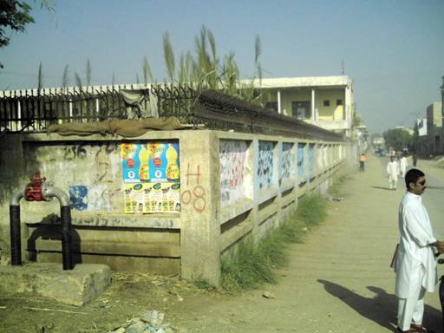
Out side View and Road Leading to Anwar Villaz.

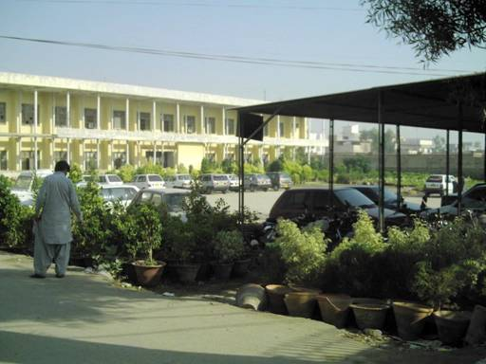
Car Parking Area

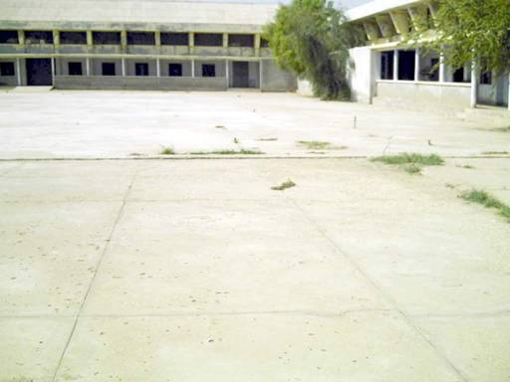
Playground for indoor Games: Volley ball / basket ball.
UTO & DIESEL TECHNOLOGY

Name of Institute/Centre/School:- Government College of Technology, Hyderabad

3.1. Name of the Major Machines/Equipments/Tools/Training Materials.
(Take more photos to clarify the condition)

S No | Name of Furniture items. | Nos. Service able. | Nos. Non Service able.
01 | Automatic Gen Box | Nil | 02 Nos
02 | Air Compressor | 01 No | Nil
03 | Armature Gruller | Nil | 01 No
a04 | Battery Charger | 01 No | 01 No
05 | Chasses Dynamometer | Nil | 01 No
06 | Compressor Color Sp | 01 No | Nil
07 | Drill Machine | 02 Nos | Nil
08 | Engine Bath Tub | 01 No | Nil
09 | Electric Motors | 02 Nos | Nil
10 | Electric Weld Plant | 01 No (Start) | Nil
11 | Engine Dynamometer | Nil | 01 No
12 | Engine Dynamo tester | Nil | 01 No
13 | Grease Gun (With Task) | Nil | 01 No
14 | Grease Roil, Oil Rail | Nil | 04 Nos
15 | Grinding Machine | 01 No Motor Burned | Nil
16 | Hanging & Boring Machine | 01 No | Nil
17 | Hydsraulics Crane | 01 No Working | Nil
18 | Injector Reconizer | 01 No | Nil
19 | Lathe Machine | 03 Nos | Nil
20 | Lift Machine | 01 No | Nil
21 | Press Machine | 01 No | Nil
22 | Power Hack Saw | 01 No | Nil
23 | Steam Washing Machine | 01 No | Nil
24 | Steeve Press | 01 No | 01 No
25 | Valve Refacer | 01 No | 02 Nos
26 | Washer Making Machine | 01 No | Nil
27 | Welding Plant | 01 No | Nil
28 | Wheel Drum Grinder | 01 No | Nil
29 | Water Pump | 01 No | For,Service Station
30 | Crank Turning Machine | 01 No | Nil

Signature of Head of Institute
AUTO & DIESEL TECHNOLOGY
.
Name of Institute/Centre/School:- Government College of Technology, Hyderabad
3.1. Name of the Major Machines/Equipments/Tools/Training Materials.
(Take more photo to clarify the condition)

S No | Name of Furniture items. | Nos. Service able. | Nos. Non Service able.
31 | Activity line Cylinder | 01 | 0
32 | Boring Tools | 30 | 0
33 | Bosch Items | 0 | 69
34 | Cutting Tools | 64 | 0
35 | Combination Plier | 0 | 6
36 | Cold Chisel | 0 | 5
37 | Chisel Punch Center | 0 | 10
38 | Color Mixing Drum | 01 | 0
39 | Depth Gauge | 0 | 5
40 | Divider | 0 | 40
41 | Fitter Tool Kit (1061) | 0 | 78
42 | Flaring tool | 0 | 2
43 | Flate File | 50 | 49
44 | Fix Spanner | 0 | 30
45 | Flath Screw Driver | 0 | 13
46 | Filler Guage | 0 | 2
47 | F. Corrgage Kit | 0 | 25
48 | Grip Plier | 0 | 1
49 | Gas Weld Torch | 03 | 0
50 | Gas Lighter | 0 | 6
51 | Gas Regulator | 04 | 0
52 | Gas Cylinder Deys | 0 | 4
53 | Half R tile | 31 | 0
54 | Hammers | 06 | 6
55 | Hack Saw Frame | 06 | 2
56 | Hand Drill | 1 | 0
57 | Hand Vice | 2 | 0
58 | Hydraulic Jack | 0 | 4
59 | Megnato | 4 | 0
60 | Mallet Rubber | 4 | 0
61 | Mallet Plastic | 4 | 0
62 | Mallet Wooden | 6 | 0

Signature of Head of Institute

AUTO & DIESEL TECHNOLOGY

Name of Institute/Centre/School:- Government College of Technology, Hyderabad
3.1. Name of the Major Machines/Equipments/Tools/Training Materials.
(Take more photo to clarify the condition)

S No | Name of Furniture items. | Nos. Service able. | Nos. Non Service able.
63 | Machine Vice | 1 | 0
64 | Needle File | 0 | 24
65 | Nose Plier | 0 | 3
66 | Needle Block | 4 | 0
67 | Oxygen Cylinder | 2 | 0
68 | Puller Kit | 20 | 0
69 | Fipe Cutter (Small) | 1 | 0
70 | Plug Spanner | 0 | 5
71 | Phillips Screw Driver | 0 | 5
72 | Pipe Vice | 1 | 0
73 | Puncture Machine | 0 | 1
74 | Ring Fix Spanner | 0 | 24
75 | Ring Spanner | 0 | 50
76 | Sleeve Socket | 0 | 6
77 | Steel Rule | 0 | 15
78 | Scriber | 0 | 14
79 | Screw Wrech | 10 | 5
80 | Scriber Wheel | 6 | 0
81 | Surface Plate | 0 | 2
82 | Tool Kit | 0 | 70
83 | Tacho Meter | 2 | 0
84 | Timing Toch | 0 | 1
85 | Try-Square | 21 | 0
86 | Tri-angle File | 30 | 0
87 | Thread Guage | 0 | 3
88 | Tyre Lever | 4 | 0
89 | Torgue Wrench | 1 | 1
90 | Tong | 6 | 0
91 | Table Vice | 20 | 0
92 | Valve Lifter | 10 | 0

Signature of Head of Institute

AUTO & DIESEL TECHNOLOGY

Name of Institute/Centre/School:- Government College of Technology, Hyderabad
3.1. Name of the Major Machines/Equipments/Tools/Training Materials.
(Take more photos to clarify the condition)

S No | Name of Furniture items. | Nos. Service able. | Nos. Non Service able.
93 | Vacuum Gauge | 1 | 0
94 | V.L.C Gauge | 1 | 0
95 | Valve Mire kit | 1 | 0
96 | W.T Kit (964) | 0 | 50
97 | Wheel Spanner | 0 | 10
98 | Wheel Stand | 2 | 0
99 | Drill Bitts N. Size | 0 | 41
100 | Drill Tapper Sink | 0 | 9
101 | Electric Weld Hold | 9 | 0
102 | Elodah Box | 0 | 1
103 | Holder Iron | 0 | 1
104 | Inside Caliper | 20 | 0
105 | Out side Calliper | 15 | 0
106 | Batter Cell Tester | 2 | 0
107 | Chipping Hammer | 6 | 0
108 | Model | 18 | 0
109 | Squire File | 0 | 3
110 | Round File | 18 | 0
111 | Wheel Alignment | 1 | 0
112 | Wheel Balance | 1 | 0
113 | Tire Changer | 1 | 0
114 | Two Pole Paner Lift | 1 | 0
115 | Ignition Analyzer | 1 | 0
116 | Crocodile Jack | 1 | 0
117 | Flex Drive Comp: Tester | 1 | 0
118 | Injection Nozzel Tester | 1 | 0
119 | Diesel Comp Tester | 1 | 0
120 | 4 Cylinder Diesel | 1 | 0
121 | 4 Cylinder Petrol | 1 | 0
122 | Mortan Tool Box | 1 | 0

Signature of Head of Institute

AUTO & DIESEL TECHNOLOGY

Name of Institute/Centre/School:- Government College of Technology, Hyderabad

3.1. Name of the Major Machines/Equipments/Tools/Training Materials.
(Take more photo to clarify the condition)

VEHICLES:-

S No | Name of Furniture items. | Nos. Service able. | Nos. Non Service able.
1 | Fiat Car 600 CC HD-6159 | 0 | 01
2 | Mini Morris HD-5915 | 0 | 01
3 | Walles Wagon HD-6742 | 0 | 01
4 | Didge Dart | 0 | 01
5 | Country Sidan HAD-6498 | 0 | 01
6 | Willys Jeep Ford HDB-6499 | 0 | 01
7 | Lay Land HAD-9479 | 0 | 01
8 | Dute (Irani Bus) 009 | 0 | 01
9 | Ford Wagon (1974) GS-7039 | 0 | 01
10 | Suzuki High Roof GS-4020 | 01 | 0

Signature of Head of Institute

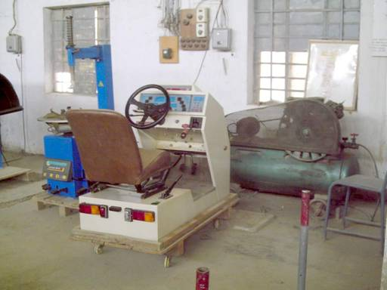
Auto-Shop

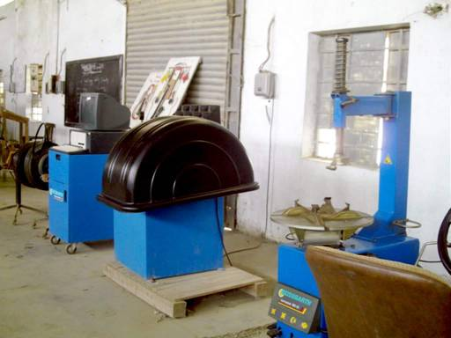
Equipments of Wheel Alignment/ Balancing in Auto-Shop

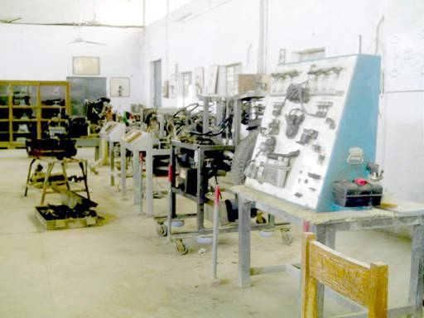
Equipments in Auto-Shop
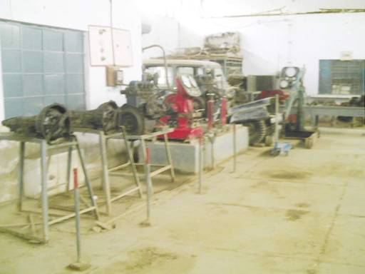
Auto-Shop
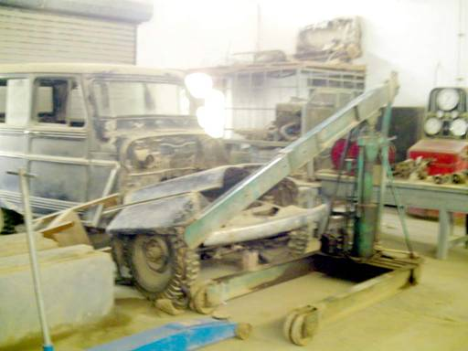
VEHICLE lying in Auto-shop

