GOVERNMENT COLLEGE OF TECHNOLOGY


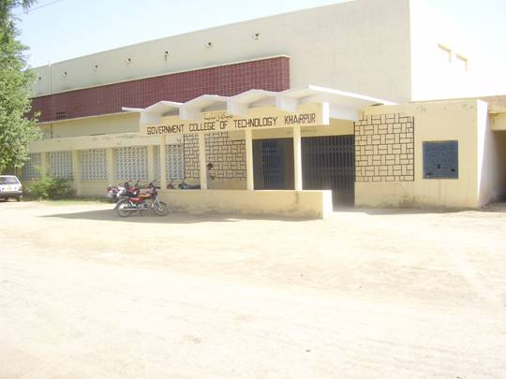
Government college of technology
Khairpur
Survey report: October 2008

(Sindh Technical Education & Vocational Training Authority)
This baseline Survey of the institute is conducted by Sindh Technical Education & Vocational Training Authority (S.TEVTA),
Through,

Engr: Muneer Ahmed Shaikh Convener.
Principal G.C.T. Khairpur.

Syed Ghanzanfar Abbas Tirmizi Member
H.O.D. (Civil).

Mr. Riaz Ahmed Arain Member
I/C H.O.D. (Mechanical).

Engr:Inayatullah Memon Member
Electrical Department

Mr. Nasrullah Phulpoto Member
Office Superintendent.
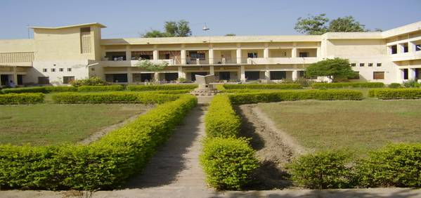

Under supervision of Engr: Raja Ghulam Hussain
CONSULTANT
Sindh Technical Education & Vocational Training Authority
Composed By. Abdul Faheem Bhutto.

Government College of Technology
Khairpur
Institute Profile.

Population, Male = …810448……. Female = …736139………… Total =…1546587......

1. Name of Institute:- Government College of Technology
Khairpur
2. Address:- Near Jinnah Colony Khairpur
Phone:- 0243, 923024-25
Fax:- 02439280170
Email:- gctkhairpur@hotmail.com
3. No. of Shifts Offered: - Two
4. Courses officered:- (A) Diploma of Associate Engineer
i. Duration of Courses:- Three Years
ii. Entry Qualification:- Matric Science/Techanical school certificate
iii. Intake Capacity in each Technology/ Course.
INTAKE /ENROLMENT
S.No | Name of Course | Morning |  |  |  |  |  |  |  | Evening (S.H.B)
S.No | Name of Course | 1st:Year |  | 2nd Year |  | 3rd Year |  | Total |  | 1st:Year |  | 2nd Year |  | 3rd Year |  | Total
 |  | In Take | Enrolment | In Take | Enrolment | In Take | Enrolment | In Take | Enrolment | In Take | Enrolment | In Take | Enrolment | In Take | Enrolment | In Take | Enrolment
1 | Civil | 50 | 60 | 50 | 44 | 50 | 52 | 150 | 156 | 50 | 72 | 50 | 46 | 50 | 22 | 150 | 140
2 | Electrical | 50 | 58 | 50 | 38 | 50 | 42 | 150 | 138 | 50 | 77 | 50 | 53 | 50 | 41 | 150 | 171
3 | Mechanical | 50 | 49 | 50 | 39 | 50 | 41 | 50 | 129 | 50 | 69 | 50 | 38 | 50 | 26 | 150 | 133
4 | Ref:&Air Conditioning | 50 | 18 | 50 | 11 | 50 | 14 | 50 | 43 | ... | ... | ... | ... | ... | ... | ... | ...
5 | Auto & Farm | 50 | 18 | 50 | 15 | 50 | 8 | 50 | 41 | ... | ... | ... | ... | ... | ... | ... | ...
Total |  | 250 | 203 | 250 | 147 | 250 | 157 | 450 | 507 | 150 | 218 | 150 | 137 | 150 | 89 | 450 | 444

iv. Present Total Enrollment:- 507 (M) + 444 (Eve:) = 951
v. No. of Application for Admission During 2007-08:- 522 (M) + 218 (Eve:) = 740
vi. No. of Candidates granted admission:- 203 (M) + 218 (Eve:) = 421
vii. Rate of Fees (a) admission fee Rs.75/- (M) (b) Monthly fee Rs. 220/-(M)
Rs. 85/-(Eve:) Rs. 535/- (Eve:)
viii. Quality of Intake 2007-08:-
A1 = 14 A = 105 B = 250 C = 120 D = 03
ix. Quality of Passers during 2006-07, Examination
.(a) 1st Division = 264 (b) 2nd Division = 111 (c) 3rd Division = Nil
Total No. of Passers = 375
4. Courses officered:- (B) Bachelor of Technology
i. Duration of Courses:- Four Years
ii. Entry Qualification:- Diploma of Associate Engineer
iii. Intake Capacity in each Technology/ Course.
INTAKE / ENROLMENT
S. No | Name of Course | B.Tech: (Pass) 1st Year |  | B.Tech:  (Pass)  2nd Year |  | Total |  | B.Tech:  (Hons)  1st Year |  | B.Tech: (Hons)  2nd Year |  | Total
S. No | Name of Course | In Take | Enrolment | In Take | Enrolment | In Take | Enrolment | In Take | Enrolment | In Take | Enrolment | In Take | Enrolment
1 | Civil | 10 | 12 | 30 | 30 | 40 | 42 | 30 | 03 | 30 | 07 | 60 | 10
2 | Electrical | 10 | 17 | 30 | 37 | 40 | 54 | 30 | Nil | 30 | 04 | 60 | 04
3 | Mechanical | 10 | 14 | 30 | 23 | 40 | 37 | 30 | Nil | 30 | 06 | 60 | 06
Total |  | 30 | 43 | 90 | 90 | 120 | 133 | 90 | 03 | 90 | 17 | 180 | 20

iv. Present Total Enrolment:- 153
v. No. of Application for Admission During 2007-08:- 180
vi. No. of Candidates granted admission:- 153
vii. Rate of Fees admission fee = Monthly Fee =
(a) B.Tech(Pass) 1st Year Rs. 4330/- (a) Rs. 361/-
(b) B.Tech(Pass) 2nd Year Rs. 4980/- (b) Rs. 415/-
(c) B.Tech(Hon’s) 1st Year Rs. 4330/- (c) Rs 361/-
(d) B.Tech(Hon’s) 2nd Year Rs. 5280/- (d) Rs 440/-
viii. Quality of Intake 2007-08:-
(Morning)
S.No | Class | Civil |  | Electrical |  | Mechanical
 |  | 1st Div: | 2nd Div: | 1st Div: | 2nd Div: | 1st Div: | 2nd Div:
1 | B.Tech: (Pass) 1st Year | 10 | 02 | 13 | 04 | 09 | 05
2 | B.Tech: (Pass) 2nd Year | 26 | 04 | 30 | 07 | 18 | 05
3 | B.Tech: (Hon’s) 1st Year | Promoted | Promoted | Promoted | Promoted | Promoted | Promoted
4 | B.Tech: (Hon’s) 2nd Year | Promoted | Promoted | Promoted | Promoted | Promoted | Promoted
ix. Quality of Passers during 2006-07, Examination.
(Morning)
S.No | Class | Civil | Electrical | Mechanical
1 | B.Tech: (Pass) | 04 | 05 | 0
2 | B.Tech: (Hon’s) | 09 | 06 | 02
 | Total | 13 | 11 | 02

Building

1. Name of Institute:- Government College of Technology khairpur.
2. Whether building is owned or hired:- Owned (Government Building)
3. Total land of Institute:- 32 Acres
4. Covered area of Building: -
(a) Ground Floor (College Building) = 119476.00 Sft
(b) 1st Floor (College Building) = 10586.00 Sft
(c) Ground Floor (Hostel Building) = 24500.00 Sft
(d) 1st Floor (T.T.T.I. Building) = 21118.00 Sft
Total Covered Area = 175680.00 Sft

5. Year of Construction/ Age of Building 45 Years (About)
6. No. of Workshops: 14
7. No. of Classrooms:- 20
8. No. of Labs:- 16
9. Library:- Yes
10. Hostel:- Yes
11. Recreation Hall/ Canteen:- No
12. Auditorium:- Yes
13. Res. Colony/Other buildings:- Yes
14. Fans/ building wise requirement:- 150
15. Play Ground:- Yes / Un - Developed
16. Tree Plantation No. of Trees:- Yes/ Adequate
17. Condition of Building: Poor
i. Construction Poor ii. Fittings/ Fixtures Poor/Inadequate iii. Electrification Poor
iv. Water Connection Poor v. Sanitary Fittings Poor/Inadequate Color/ Paint Poor
18. Availability of Drinking water: Yes/ Adequate
19. Electricity: Yes
20 Water Cooler 06 No. In - Serviceable
21 Transportation Bus (52 Setter) Running Condition(01 No.)
20. Nature of repairs required for College & Staff Colony:
i. Major Repair & Replacement of R.R.C. Roof, Floors, Doors &Windows and Plaster of walls.
ii. White washing/ Colour washing of all buildings

iii Painting of doors and windows
iv. Reconditioning & Constructions of internal Roads
v. Repair of Main Gate of College and boundary wall.
vi. Water Supply and Drainage Scheme for college & residential colony.
vii. Supply and fixing of water supply and sanitary fitting and fixtures
viii. Installation of Electric Transformer 2 No. (200KVA).
ix. Replacement of LT Transmission Line.
x. Internal Electrification/ Street Lighting of the campus.
xi. Renovation and Beautification work of the campus.

21. Missing facilities if any:
- Transport for staff & students.
- Canteen for staff & students.
- Electric Water Cooler.
- Office Equipments.
- Latest Library Books/ Well equipped Library.
- Latest Machinery/ Equipments for all Technologies.

22. Whether occupied by any other agency: -NIL-
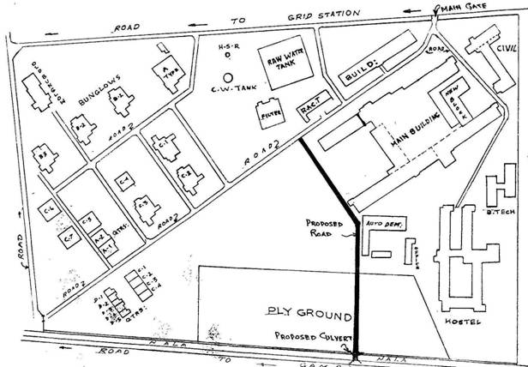
Location Plan

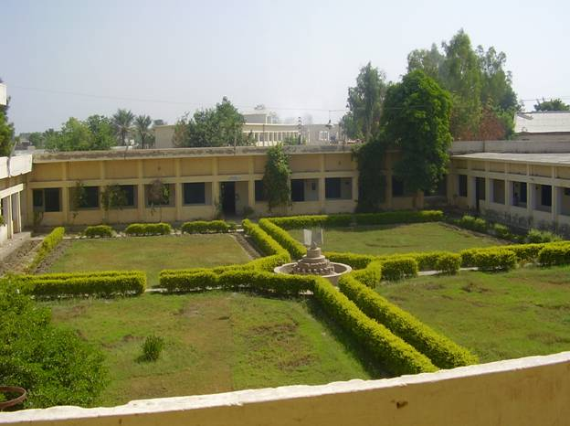
CENTRAL LAWN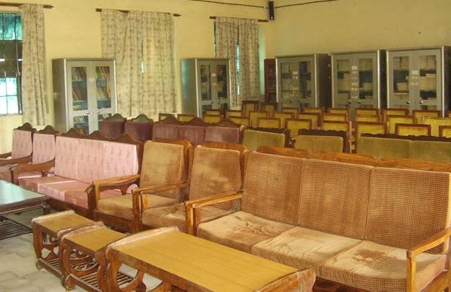

Conference Hall
Summary of Survey

Originally this Institute was introduced as “Sir Ali Murad Technical Institute” which was subsequently up graded to the level of polytechnic Institute by Government of West Pakistan in the year 1962. Since 1974, it has been further up Graded as “Government College of Technology” Khairpur; with the introduction of B.Tech Programme.
College is situated near to Khairpur Railway station at about 1-km towards East. It is spread over an area of 32 acres having sufficient accommodation for class rooms, labs, workshops, Auditorium, library Hall, Administration block, Students Hostel & Residential accommodation for the staff is also available.
College is working under the Administrative control of Education & Literacy Department Government of Sindh. The budget is allotted by the Government of Sindh through Directorate of Technical Education Sindh Karachi .The College is offering 3-years Diploma of Associate Engineer (DAE) Morning Programme in Auto & Farm, Civil, Electrical, Mechanical & Refrigeration & Air conditioning Technologies & Civil, Electrical & Mechanical Technologies under Self Help Basis ( S.H.B) Evening programme. B.Tech (Pass / Hons) Courses in Civil, Electrical & Mechanical Technologies, are also offered in Morning programme only. The college is affiliated with Sindh Board of Technical Education (S.B.T.E) Karachi for DAE courses & with Quid-e-Awam University of Engineering Science & Technology (QUEST) Nawabshah with regards to B-Tech. Degree programme.
The college has a computer Lab, well equipped with P-IV computers & a Library containing old collection of about 15000 books for DAE / B.Tech. Students.
Although the main portion of the building is too old & is constructed in early 60’s, is turned to poor condition. The residential accommodation of staff is also in bad condition. Roof , Floors, Drainage system, Water supply system, Electrical Fittings, Internal Electrification, Door & Windows, Fittings & Fixtures are also in very poor condition, as the repair works of residential colony & college building had not been carried out by the Government since so many years. The internal roads of the campus are in very poor condition as no repairs had been carried since construction of these roads.
The Institute has its own Transformer of 200 KVA which is installed about 30 years back, which is repaired for three times due to over loading / electrical faults, the condition of internal electrification of college & campus is also not so good. The LT transmission line & electric poles are installed about 30-years back, which are in bad condition and needs immediate replacement The institute is running with inadequate & old /out dated equipments, most of the machines in various departments are in working condition. Equipment of science & other labs are inadequate.

The B.Tech Degree programme is running without its Academic & Works Shop blocks since its introduction in the year 1974. The programme is running in the portion of Building meant for hostel of B.Tech students.
The Govt. of Sindh has established a Provincial Institute for Training of the Technical Teachers with the assistance of Asian Development Bank in the year 2002. The scheme was originally established at Sukkur then shifted to Government College of Technology Khairpur campus in 2004-05 & established at the 1st floor of Hostel block with some addition and alterations the institute is not functionalized as yet due to non availability of staff & budget. The ground floor of Hostel block is used for DAE / B.Tech students of this college.
Recently, the Government of Sindh has been pleased to establish a newly Petroleum Technical Training Institute (P.T.T.I) at this College with the collaboration of Ministry of Petroleum & Natural Resources, Government of Pakistan. The adequate building portion is available for academic block, however workshop block & students hostel is to be constructed/ renovated by the Government.
The college is facing acute shortage of Teaching & Non-Teaching staff, only 38% teaching staff is available at this college & 62% Non Teaching staff is working since long.
To meet the Teaching & Non-Teaching requirements, the institute administration has engaged part time contract staff on purely temporary basis under Self Help Basis (S.H.B) Evening Programme.

Auto & Farm technology
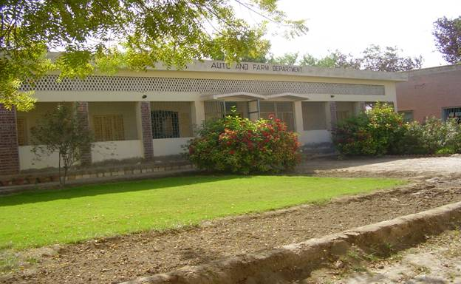

Physical Facilities.

3.1. Name of the Major Machines/ Equipments/ Tools/ Training materials.

S.No | Name of Lab/Work Shop/Building/ | Nos. | Condition Good/Fair/Bad | Remarks
1 | Building Condition | 01 | Fair
2 | Class Room | 02 | Good
03 | Class Room | 01 | Poor
04 | Engine Instrumentation of Testing Lab | 01 | Poor
05 | Service Station Shop | 01 | Poor
06 | Agriculture Shop | 01 | Poor
07 | Engine Shop | 01 | Poor
08 | Staff Office | 06 | Poor
09 | Toilets and Wash Room | 02 | Poor
10 | Electrification |  | Poor
11 | Computer | Nil
12 | Telephone | Nil
13 | Electric Water Cooler/ Drinking water | Nil

3.2 Furniture ITEMS

S.NO | Name of Major Items / | Qty: | Serviceable |  | Repairable |  | Remarks
S.NO | Name of Major Items / | Qty: | Yes | No. | Yes | No | Remarks
1 | Almirah Steel | 06 | 02 |  | 04
2 | Chairs Wooden | 02 | --- | --- | 02 | ---
3 | Table Wooden | 01 | ---- | ---- | ---- | ---
4. | Table Steel | 01 | ---- | ---- | 01 | ---

3.3 laboratories with equipments

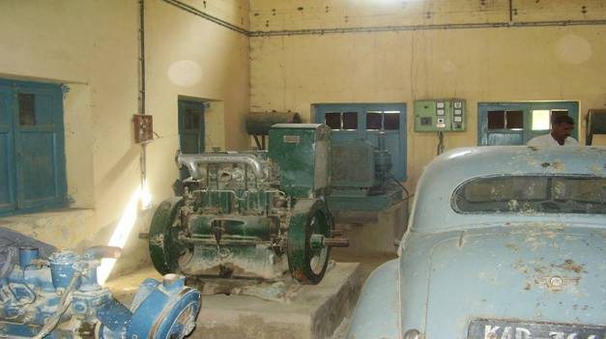

engine instrumation and testing lab.

S.NO | Name of Major Equipments | Qty: | Serviceable |  | Repairable |  | Remarks
S.NO | Name of Major Equipments | Qty: | Yes | No. | Yes | No | Remarks
1 | Drill Machine | 01 |  |  | 01
2. | Grinding Machine | 01 | 01 | -- | --- | --
3. | Diesel Generator | 02 | -- | -- | 02 | ---
4 | Gasoline generator | 01 | -- | -- | 01 | --
5. | Sliding weight weighing Machine | 02 | -- | -- | 02 | ---
6. | Cylinder boring Machine | 01 | -- | --- | 01 | --
7. | Lath Machine | 01 | -- | -- | 01 | ---
8. | Broke Drum lathe | 01 | -- | --- | 01 | ---
9. | Spry Gum Machine | 01 | --- | --- | 01 | --
10 | Battery charger | 01 | --- | --- | 01 | ---
11 | Armature Testing Generator | 01 | 01 | --- | --- | ---
12 | Hydraulic Jack (trolley type) | 01 | 01- | --- | --- | --
13 | Diesel compression tester | 01 | 01 | --- | --- | --
14 | Nussbaum 2 post hydraulic power lift | 01 | 01 | --- | --- | --
15 | Enginition analyzer Modd: 240 | 01 | 01 | ---- | --- | ---
16 | Wheel Balancer | 01 | 01 | ---- | --- | ---
17 | Diesel Engine one cylinder | 01 | --- | --- | 01 | ---
18 | Diesel Engine Two cylinder | 01 | --- | --- | 01 | ---
19 | Diesel Engine Four Cylinder | 01 | --- | --- | 01 | ---
20 | Power Hack Saw | 01 | ---- | --- | 01 | ---
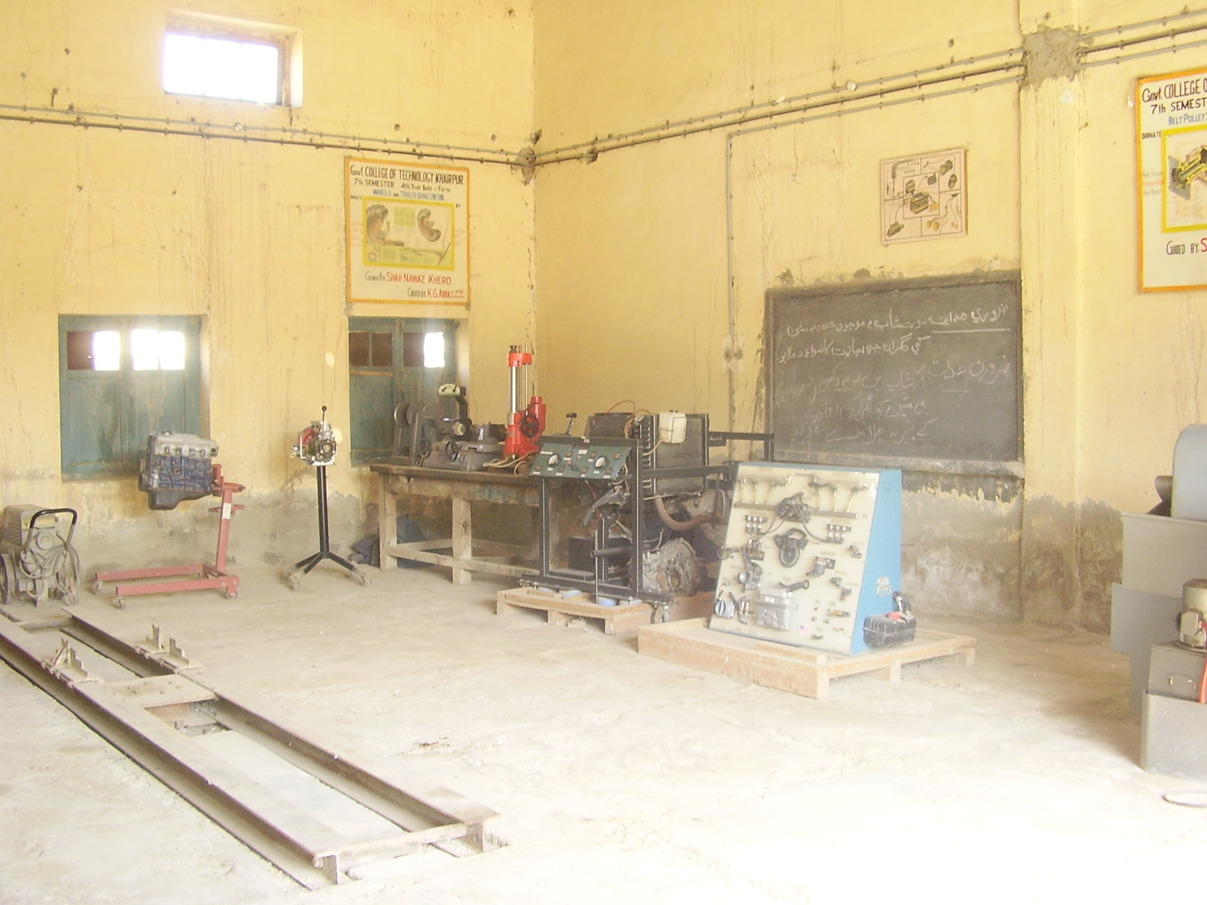
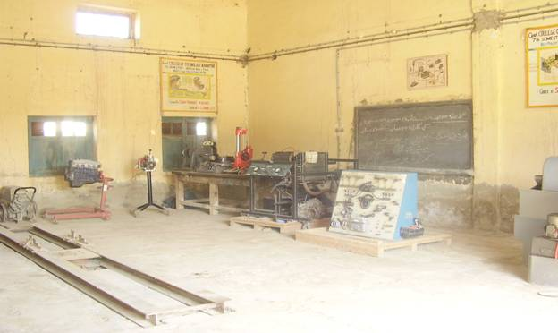

Service station shop

S.NO | Name of Major Items | Qty: | Serviceable |  | Repairable |  | Remarks
S.NO | Name of Major Items | Qty: | Yes | No. | Yes | No | Remarks
1 | Hydraulic Vehicle | 01 | 01 | -- | --- | ---
2 | Hydraulic Crank Shaft grinder | 01 | 01 | --- | --- | -
3 | Valve refacing Machine | 01 | 01 | ---- | ---- | -
4. | Lath Machine | 01 | 01 | ---- | --- | ---
5. | Cylinder Boring Machine | 01 | 01 | --- | ---- | ---
6 | Manual Transmission Progrm: | 01 | 01 | --- | -- | --
7 | Suspension and staring system | 01 | 01 | ----- | --- | --
8 | Fuel Indication Trainer | 01 | 01 | ----- | ---- | ---
9 | Wheel Aligner Macro Line 300 PSI | 01 | 01 | ---- | --- | --
10 | Pneumatic power tire charger | 01 | 01 | --- | -- | --
11 | Steering Box croul | 01 | 01 | ---- | - | --
12 | Pre- driving training & with reacter time meter | 01 | 01 | ---- | ---- | ---
13 | Flex drive compression tester | 01 | 01 | --- | --- | --
14 | Professional vacuumed & fuel tester | 01 | 01 | ----- | ---- | --
15 | Battery charger | 01 | 01 | ---- | -- | ---
16 | Master Tool Box craft Main tool | 01 set | 01 | ---- | --- | ---
17 | Injection Nozle Tester | 01 | 01 | ---- | --- | ---
18 | Four cylinder Petrol Engine Local | 01 | 01 | --- | --- | -
19 | Four Cylinder Diesel Engine Local | 01 | 01 | --- | -- | --
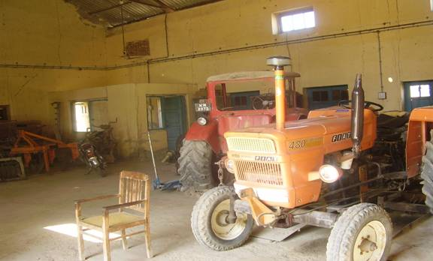
Agriculture shop

S.NO | Name of Major Items | Qty: | Serviceable |  | Repairable |  | Remarks
S.NO | Name of Major Items | Qty: | Yes | No. | Yes | No | Remarks
1 | Tractor 12 HP | 01 | --- | --- | 01 | ---
2 | Flat Tractor (480) | 01 | 01 | --- | --- | --
3 | Russian Balarus Tractor MTZ 50 | 01 | ---- | --- | 01 | ---
4. | Two Wheel Tractor | 01 | --- | --- | 01 | ---
5. | Roota Vator plow | 01 | 01 | --- | --- | --
6 | MB Plow for MTZ 50 | 01 | --- | -- | 01 | ---
7 | Horvester | 01 | --- | No | -- | NO
8 | Spryer | 01 | --- | --- | 01 | ---
9 | Oil Function Gum | 01 | 01 | --- | --- | --
10 | Land levler | 01 | 01 | --- | --- | --
11 | Disk Harrow for MTZ 50 Tractor | 01 | 01 | --- | --- | --
12 | Disk Plow 3 furrow for MTZ 50 Tractor | 01 | 01 | --- | --- | --
13 | Wheel Drill | 01 | --- | -- | 01 | ---
14 | Hydraulic Automatic lift | 01 | -- | -- | 01 | --
15 | 30 Gallon Skid & Trailer Sprayer | 01 | 01 | --- | --- | --
16 | Power Earth Auger: Post hold digger | 01 | 01 | --- | --- | --
17 | Raja Plow | 01 | 01 | --- | --- | --
18 | Land Roller | 01 | 01 | --- | --- | --
19 | Cotton Seed Drill | 01 | 01 | --- | --- | --
20 | D.D.T Sprayer | 02 | -- | -- | 02 | ---
21 | Fuel Injection Pump | 01 | 01 | --- | --- | --
22 | Table Drill Machine | 01 | 01 | --- | --- | --
23 | Chain Lifter with stand | 01 | --- | --- | 01 | ---
24 | Thresher | 01 | 01 | --- | --- | --

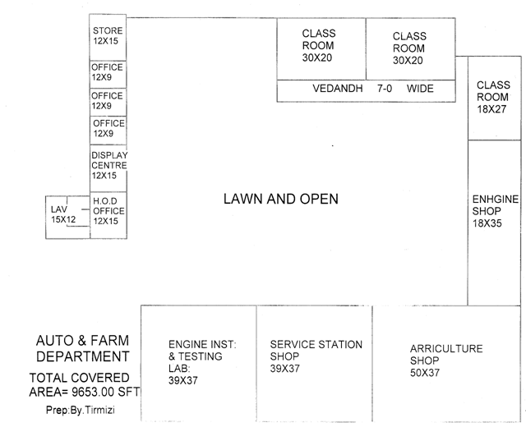

rafrigration & air conditioning.

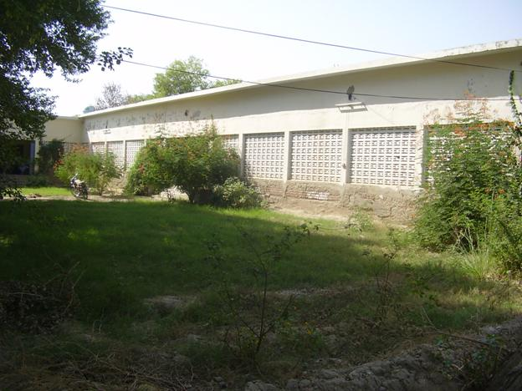

Physical Facilities.

3.1. Name of the Major Machines/ Equipments/ Tools/ Training materials.

S.No | Name of Lab/Work Shop/Building/ | Nos. | Condition Good/Fair/Bad | Remarks
1 | Building condition | 01 | Fair
2 | Class Room | 01 | Fair
03 | Comprehensive Shop | 01 | Poor
04 | Advance Shop | 01 | Poor
05 | Drawing Hall | 01 | Poor
06 | Offices | 03 | Fair
07 | Electrification |  | Poor
08 | Computer | Nil
09 | Telephone | Nil
10 | Electric Water Cooler/ Drinking water | Nil

3.2 FURNITURE ITEMS

S.NO | Name of Major Items / | Qty: | Serviceable |  | Repairable |  | Remarks
S.NO | Name of Major Items / | Qty: | Yes | No. | Yes | No | Remarks
1 | Almirah Steel | 01 | -- | --- | 01 | ---
2 | Office Chairs Wooden | 03 | 03 | --- | --- | ---
3 | Office Table Wooden | 01 | 01 | --- | --- | ---
4. | Drawing Stool | 40 | 15 | --- | --- | 35
5. | Ceiling Fan | 02 | --- | --- | 02 | ---

3.3 laboratories with equipments

DRAWING HALL

S.NO | Name of Major Items | Qty: | Serviceable |  | Repairable |  | Remarks
S.NO | Name of Major Items | Qty: | Yes | No. | Yes | No | Remarks
1 | Drawing Board | 40 | 15 | --- | --- | 35 | Broken
2. | Drawing Table | 40 | 15 | -- | -- | 35 | Do
3. | Drawing Tee | 40 | 15 | -- | -- | 35 | Do

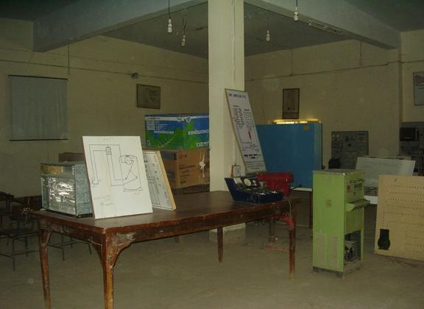

advance refrigration shop

S.NO | Name of Major Items | Qty: | Serviceable |  | Repairable |  | Remarks
S.NO | Name of Major Items | Qty: | Yes | No. | Yes | No | Remarks
1 | Industrial Refrigeration Training System | 01 | 01 | ---- | --- | ---
2. | Air Condition Unit | 01 | 01 | -- | -- | ---
3. | Recovery Arocraly system unit | 01 | 01 | -- | -- | ---
4 | Refrigeration cycle | 01 | 01 | --- | --- | ---
5 | Semi Hermetic completion Unit | 01 | 01 | --- | --- | --
6 | Heating & Air Conditioning Wire traneer | 01 | 01 | -- | --- | ---
7 | General cycle refrigeration trainer | 01 | 01 | --- | --- | --
8 | A/C Packaged type | 01 | 01 | --- | --- | --
9 | Working table | 04 | 04 | - | --- | ---
10 | Electric Drill Machine | 03 | 03 |  | Yes
11 | Electric Drill Machine | 01 | 01 |  | Yes
12 | Electric Welding Plant | 01 | 01 |  | Yes
13 | Water Cooler | 02 | 02 |  | Yes
14 | Refrigerator | 02 | 02 |  | Yes
15 | Deep Freezer | 02 | 02 |  | Yes
16 | A/C Window | 03 | 03 |  | Yes
17 | A/C Window | 01 | 01 |  | Yes

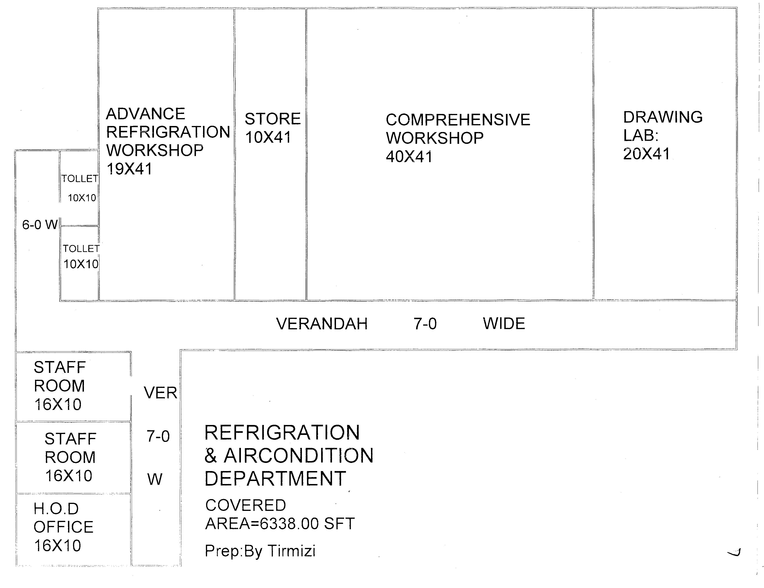
BACK VIEW OF AUTO & FARM.

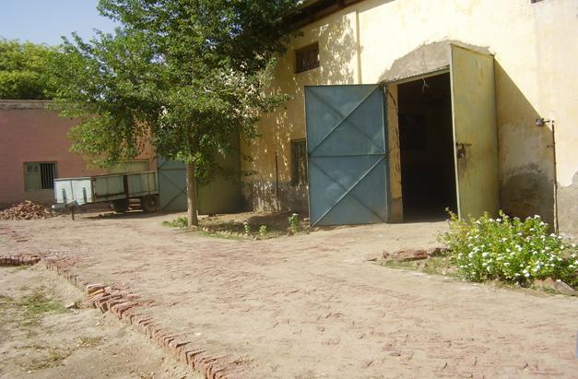
ROAD OF AUTO & FARM DEPARTMENT.

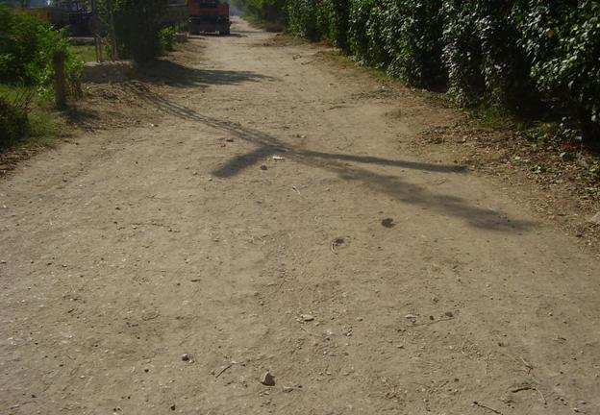
Internal Road to Colony
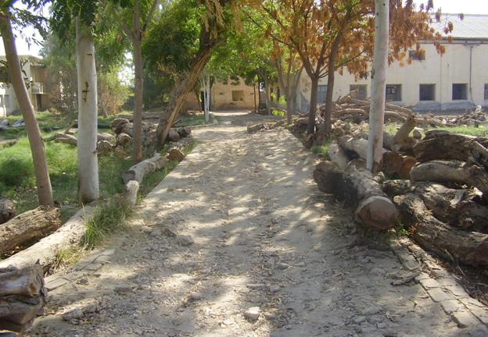
Internal Road to Auto & Farm Department

